
BATH BRANCH
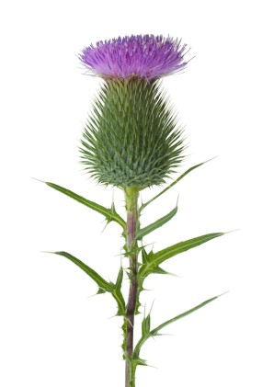
New Year Dance

Bathampton Village Hall, Holcombe Lane, BA2 6UL

Saturday 17th January 2026
Mulled Wine and Mince Pies 7.00 pm
Dancing 7.30 pm – 10.30 pm

All dances are walked through once, dancing to The Dewhurst Duo

M C. Jane Hammond

Granville Market J 32 x 8 Merrie Mayhem R32 x 8
Maxwell’s Rant R 32 x 8 Minister on the Loch S 32 x 8
S-Locomotion S 32 x 4 White Heather Jig S 40 x 4
Quarries’ Jig J 32 x 8 The Sailor R 32 x 8
Polharrow Burn R32 x 5 Dreamcatcher S 96
Cranberry Tart J 32 x 8 Waternish Tangle J 32 x 8
Sugar Candie S32 x 8 Cherrybank Gardens S 32 x 3
Roselath Cross J 32 x 8 Flight of the Falcon J 32 x 8
Irish Rover J 32 x 8 Reel of the 51st J 32 x 8

INTERVAL
Tickets: £12
Bank Transfer details:
RSCDS Bath Account No. 04458244 Sort Code: 30 90 54
Cash acceptable on door but email to say you wish to come.

Telephone: 07810441130 (Anne)
Email: annejarrett@btopenworld.com for more details

Dress: Informal

Please book your place as numbers are limited

American Supper: Contribution to the supper table please.

Reg Charity: 107460

End of Term Christmas Dances

Machine without Horses J 32 x 8;
Maxwell's Rant R 32 x 8;
Minister on the Loch S 32 x 3;
Quarries' Jig J 32 x 8 ;
Scott Meikle R 32 x 4;
Roselath Cross J 32 x 8;
Sugar Candie S 32 x 8 ;
Flight of the Falcon J 32 x 8;
Merry Mayhem R 32 x 8;
Cherrybank Gardens S 32 x 3;
Luckenbooth Brooch J 32 x 8;
Mrs MacPherson of Inveran R 32 x 8.

