

BATH Royal Scottish Country Dance Society and Corsham Scottish Dancers

Summer Afternoon Tea Dance in New Farm Barn with sprung floor
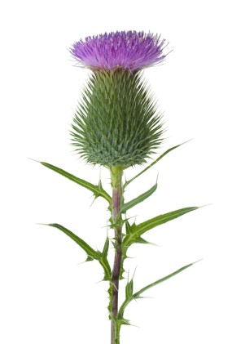
Corsham Road, Thingley, Nr Corsham (Directions provided with ticket as postcode not helpful)
Friday 5th June 2026
Dancing 2.30 to 5.30 followed by Afternoon Tea
Tickets £12

All dances are walked through once, dancing to Strathallan Duo

MC: Peter Harraway

Welcome to Ayr The Royal Deeside Railway
The Falls of Rogie Mrs Stuart’s Jig
The Water of Leith Tullynessie and Forbes Hall
Pelorus Jack Miss Johnstone of Ardrossan
Toast to the Mousies The Hazel Tree
The Paisley Weavers The Lammermuir Hills
Farewell to Balfour Road Joie de Vivre
The Falkirk Lass The Wind on Loch Fyne
The Highland Rambler The Reel of the 51st Division

INTERVAL {drinks and biscuits)

Tickets from: Sue Colebourne colebourne804@btinternet.com
If paying by bank transfer, please email Sue to let her know.
Dance Secretary: 07810 441130 (Anne) Email: annejarrett@btopenworld.com

Bank Transfer details:
RSCDS Bath Account No. 04458244 Sort Code: 30 90 54

Shared Afternoon Tea Contributions to the table please

https://my.strathspey.org/dd/list/68650/ Dances on Video

Reg Charity: 1074609

